Local Green Space Submission for The Croft, Penkhull

Stoke-on-Trent City Local Plan
7th issue to City of Stoke-on-Trent Planning Services
updated October 2025

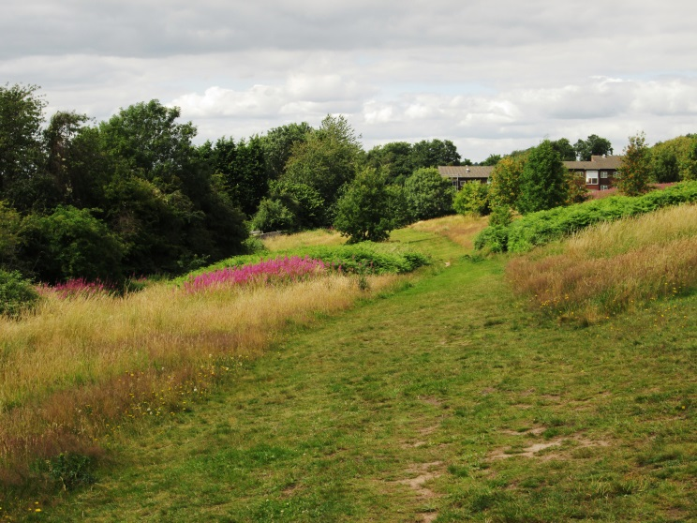

Contents

List of Abbreviations
1 Introduction 1
1.1 Background 1
2 National Planning Policy Context 3
2.1 National Planning Policy Framework 3
2.2 National Planning Practice Guidance 3
2.3 UK Biodiversity Action Plan 4
2.4 Natural Environment and Rural Communities Act 2006 and Environment Act 2021 4

3 Local Planning Policy Context 6
3.1 City of Stoke-on-Trent Local Plan 2001 6
3.2 Newcastle-Under-Lyme and Stoke-On-Trent Core Spatial Strategy 6
3.3 Urban North Staffordshire Green Space Strategy 7
3.4 Stoke-on-Trent Greenspace Strategy (2014) 7
3.5 The Stoke-on-Trent Biodiversity Opportunity Mapping 8
3.6 City of Stoke-on-Trent Green Space Strategy November 2018 8
3.7 Stoke-on-Trent City Council and Newcastle-under-Lyme Borough Council Joint Local Plan: Natural and Rural Environment Technical Paper (2018) 9
3.8 Stoke-on-Trent Green Space Strategy 2021 9

4 Non Statutory Policies and Guidance 10
4.1 Staffordshire Biodiversity Action Plan 10
4.2 Nature Nearby - Accessible Natural Green Space Guidance 10
4.3 Guidance for Outdoor Sport and Play: Beyond the Six Acre Standard 10
5 Planning History 11
5.1 Applications 11
5.2 Development allocation 11
6 ‘The Croft’ a Local Green Space 12
6.1 Introduction 12
6.2 NPPF LGS Designation criteria 12
6.3 Creating Healthy Places 16
7 Summary 18
7.1 The Croft as a Local Green Space 18

Appendix A - Plan of The Croft
Appendix B - Photographs of The Croft
Appendix C - Richness of Wildlife-Biodiversity

Appendix D - Community Comments: NPPF para 100 b

References

List of Abbreviations
ANGSs | Accessible Natural Green Space Standard
AOD | Above Ordnance Datum
BAP | Biodiversity Action Plan
BoCC 4 | Birds of Conservation Concern 4 2015, Red or Amber
FC | Friends of The Croft
GI | Green Infrastructure
LGS | Local Green Space
LPA | Local Planning Authority
NERC | Natural Environment and Rural Communities Act
NPPF | National Planning Policy Framework
OS | Ordnance Survey
PPG | National Planning Practice Guidance
PPPs | Planning Policy Statements
PRA | Penkhull Residents Association
SA | Sustainability Appraisal Scoping Report (April 2021)
SBAP | Staffordshire Biodiversity Action Plan
UK BAP | UK Biodiversity Action Plan

Introduction

Background

This submission has been prepared jointly by the Penkhull Residents Association (PRA) and the Friends of The Croft (FC).

This Local Green Space submission was originally prepared when Stoke-on-Trent City Council had commenced the preparation of a Joint Local Plan with Newcastle-under-Lyme Council but work on this Joint Local Plan was stopped in December 2020. A stand-alone Local Plan for the Stoke-on-Trent City Council area is currently being undertaken, which once adopted, will replace the Core Spatial Strategy and Saved Local Plan policies.

In this submission where relevant, and in the public domain, reference is still made to Joint Local Plan documents where new Local Plan documents are not yet available for example, under para 3.7 and 5.2 in this report

At the time of updating this submission in May 2021 Stoke-on-Trent City Council had two documents in the public domain; A Sustainability Appraisal Scoping Report (SA) (April 2021) and a Stoke-on-Trent Local Plan Issues and Options Consultation Summary (May 2021). These reports include objectives which support the proposal to allocate the Croft as a Local Green Space. The SA objectives will be used to undertake the sustainability appraisals for each stage of the current Local Plan preparation process.

Purpose

The submission seeks to provide Stoke-on-Trent City Council, the local planning authority (LPA), with robust and well documented evidence to enable the LPA to designate the area of grassland, hedgerows and trees, to the south–west of Thistley Hough Academy, and known locally as ‘The Croft’ (also referred to as the Lower Croft) as a Local Green Space (LGS).

The importance and benefits of local green space for our health and well-being has been widely recognised by both national and local government for a number of years. This was particularly relevant currently when COVID-19 social distancing required large accessible open spaces for people to exercise in. This reassessment of the community use of urban open space highlights The Croft as an essential resource.

Structure of this report

The submission outlines the key elements of national and local planning policy with particular reference to the significance of green infrastructure and green space within our communities and its role in promoting good health and wellbeing.

It summarises non statutory guidance related to green open spaces, recreation and the importance to biodiversity that these areas provide.

There is a detailed analysis of the criteria for the designation of Local Green Spaces as defined in the Government National Planning Policy Framework and associated Guidance documents followed by evidence of how The Croft meets these criteria.

The appendices, A, B, C and D includes a scale map of the proposed Croft LGS, photographs, lists of some of the plant and animal species identified on The Croft and Community Comments with reference to NPPF para 100 b

Landownership and Consultation With The City

In parallel to the preparation of this LGS submission the Penkhull Residents Association have consulted and entered into discussions with Stoke-on-Trent City Council, Property and Estates, as landowner of The Croft, The City Planning Policy Team Principal Planning Officer and the Strategic Manager Planning Services.

In mid-November 2020 a ZOOM meeting was held between the Estates Property and Facilities Manager, a representative of The Penkhull Residents Association and the Friends of The Croft. The meeting concluded with the Facilities Manager giving the landowners' support in principle to the Lower Croft being designated a Local Green Space. A visit to the Croft (subject to COVID-19 guidance at the time allow) was arranged for early December 2020.

The December 2020 site visit involved a socially distanced meeting to view the key features of The Croft and its context. At the end of the site visit the Estates Property and Facilities Manager confirmed that the City, as landowner of The Croft, supported the area being designated as a Local Green Space. It was agreed that the Facilities Manager would advise the Principal Planning Officer, by email, of this fact and the desire for The Croft, as described in this report, to be identified as a Local Green Space in the Stoke-on-Trent City Local Plan (the Local Plan)

National Planning Policy Context

National Planning Policy Framework

The National Planning Policy Framework (NPPF) July 2018, amended February 2019 outlines the Local Green Space designation. In the section on ‘Open Space and Recreation’ (pages 28/29 para 96, 98, 99, 100 and 101) it notes:
- ‘Access to a network of high quality open spaces and opportunities for sport and physical activity is important for the health and well-being of communities. Planning policies should be based on robust and up-to-date assessments of the need for open space, sport and recreation facilities (including quantitative or qualitative deficits or surpluses) and opportunities for new provision. Information gained from the assessments should be used to determine what open space, sport and recreational provision is needed, which plans should then seek to accommodate’ (para 103).
- ’Planning policies and decisions should protect and enhance public rights of way and access, including taking opportunities to provide better facilities for users, for example by adding links to existing rights of way networks including National Trails’(para 105).
- ’The designation of land as Local Green Space through local and neighbourhood plans allows communities to identify and protect green areas of particular importance to them. Designating land as Local Green Space should be consistent with the local planning of sustainable development and complement investment in sufficient homes, jobs and other essential services. Local Green Spaces should only be designated when a plan is prepared or updated, and be capable of enduring beyond the end of the plan period’.(para 106)
- ’The Local Green Space designation should only be used where the green space is:
- in reasonably close proximity to the community it serves;
- demonstrably special to a local community and holds a particular local significance, for example because of its beauty, historic significance, recreational value (including as a playing field), tranquillity or richness of its wildlife; and
- local in character and is not an extensive tract of land’.(para 107)
- ‘Policies for managing development within a Local Green Space should be consistent with those for Green Belts’. (para 108)

National Planning Practice Guidance

The National Planning Practice Guidance (PPG): ‘Open space, sports and recreation facilities, public rights of way and local green space’; published March 2014 notes that
- ‘Open space should be taken into account in planning for new development and considering proposals that may affect existing open space’ (PPG para 1).
- ‘Open space, which includes all open space of public value, can take many forms, from formal sports pitches to open areas within a development, linear corridors and country parks. It can provide health and recreation benefits to people living and working nearby; have an ecological value and contribute to green infrastructure’ (PPG para 1),

The PPG includes further guidance on the LGS designation. The guidance addresses questions relating to what sort of sites would be suitable for LGS designation and what the designation means in practice. The following paragraphs in the PPG are of particular relevance for the evaluation of sites for LGS designation. Key points are summarised below:
- LGS designation should be consistent with local planning for sustainable development and should not be used in a way that undermines this aim of plan making. (PPG para 7)
- Generally LGS designation is rarely appropriate for land which is subject to planning permission for development. (PPG para 8)
- The proximity of a LGS to the community it serves will depend on local circumstances, including why the green area is seen as special e.g. if public access is a factor, then the site should be in easy walking distance. (PPG para 14)
- There are no hard and fast rules about how big a LGS can be because places are different and a degree of judgement will inevitably be needed. (PPG para 15)
- Some areas that may be considered for designation as LGS may already have largely unrestricted public access, however land could be considered for LGS designation if there is no public access (e.g. if valued for biodiversity, historic significance and/or beauty). LGS designation in itself does not confer any rights of public access over what exists at present. (PPG para 17)

UK Biodiversity Action Plan

Within the UK Biodiversity Action Plan (UK BAP) 1992 there are priority habitats covering a wide range of semi-natural habitat types, with those identified as being the most threatened and requiring conservation action. The UK BAP was succeeded in July 2012 by the 'UK Post-2010 Biodiversity Framework', however the list of priority habitats remains an important reference source and was used to prepare the statutory lists of priority habitats, as required under NERC Act 2006.

UK national biodiversity strategy and action plan 2025 aims to reverse loss of biodiversity

Natural Environment and Rural Communities Act 2006 and Environment Act 2021

Under section 41 of the Natural Environment and Rural Communities (NERC) Act (2006) habitats and species “of principal importance for the purpose of conserving biodiversity” were identified which needed to be taken into consideration by a public body when performing any of its functions, i.e. to ensure that biodiversity is an integral element of policy and decision making.

The Environment Act 2021 builds on the NERC Act with legally binding targets to reverse the decline of nature by 2030 and requires local authorities to take action for nature recovery

The Biodiversity Strategy 2020 (2011) outlines the wildlife and ecosystem services strategy, and is incorporated into the NPPF and PPG, with a key aim of improving habitat quality of priority habitats.

The Croft and its Biodiversity

A range of habitats are identified as being of Principal Importance, and these include lowland grassland and meadows and lowland mixed deciduous woodland habitats, both of which are present on The Croft. There are also a number of species of Principal Importance, and those which have been found on The Croft are indicated within the species list in Appendix C - Richness of Wildlife-Biodiversity of this submission.

Local Planning Policy Context

City of Stoke-on-Trent Local Plan 2001

The City of Stoke-on-Trent Local Plan September 1993 stated that ‘Green wedges, open spaces, ridge-lines, and canal and river corridors will maintain the open character of the City, keep separate individual areas, assist nature conservation, and provide needed recreational provision. Together with the protection and conservation of historic buildings and areas, they will form an important element in improving the quality of life in the City. Strong development control policies will prevent unnecessary or inappropriate development and safeguard habitats’ (para 28). The importance of existing open spaces was further outlined under policy GP9.

The Croft

Under this Local Plan the green space and recreational provision of The Croft was recognised and it was designated as Open Space.

Newcastle-Under-Lyme and Stoke-On-Trent Core Spatial Strategy

The Local Development Framework Newcastle-under-Lyme and Stoke-on-Trent Core Spatial Strategy 2006-2026 adopted October 2009 noted that ‘To be judged as sound the Core Spatial Strategy must be consistent with national planning policy. This Core Spatial Strategy works within, and takes account of, the national policy framework. This is largely provided through Planning Policy Statements (PPSs), or Planning Policy Guidance notes (PPGs), which set out the Government's national policies on different aspects of planning’ (para 2.9)

It made reference to the Community Strategy for the City of Stoke-on-Trent adopted 2004 which identified six key priorities:

• A Healthier City

• A Safer City

• A Wealthier City

• A Greener City

• A Learning City

• A City with a Strong Sense of Community

Under the section on Greenspace the Strategy notes ‘The sub region’s urban centres benefit from an extensive network of formal and informal green spaces, all of which provide a valuable contribution towards recreational space, amenity, and wildlife habitats within the urban fabric. The mix of greenspace and built development heightened by local ridge and valley topography is a distinctive feature of the conurbation’. (para 3.42)

Strategic Aim 13 (SA13) – ‘To protect and improve the plan area’s network of canals and watercourses, green spaces/infrastructure and parks to provide the landscape setting for high quality development of homes, employment and leisure opportunities; opportunities for physical activity and to foster a more sustainable way of life’ (para 4.18)

Policy CSP4 – Natural Assets - ‘The quality and quantity of the plan area’s natural assets will be protected, maintained and enhanced through the following measures – 1. Working with relevant partners to enhance the plan area’s natural habitats and biodiversity to achieve the outcomes and targets set out UK Biodiversity Action Plan, the Staffordshire Biodiversity Action Plan and the Staffordshire Geodiversity Action Plan’ (para 6.31)

Open Space/Sport/Recreation –Stoke-on-Trent’s adopted Community Strategy identifies a clear link between the provision of high quality public open spaces and recreational facilities, and the health and wellbeing of the community.

The provision of good quality parks and green space is an essential element in creating sustainable communities. The development of good quality parks and green space should be recognised as having a significant contribution in attaining wider environmental, economic and social regeneration ambitions:
- Environmental benefits: by promoting biodiversity, improving environmental quality and responding to the need to adapt to, and mitigate the effects of, climate change
- Economic regeneration: by creating attractive settings for inward investment and elevating housing market values
- Social benefits: by providing space for recreation, play, exercise and relaxation, by providing health benefits, by creating safer environments and reducing crime, by presenting opportunities to experience and learn at first-hand about our natural environment and by providing a community focus and common ground where people can come together to demonstrate and celebrate diversity’ (para 6.38/39)

Urban North Staffordshire Green Space Strategy

The Urban North Staffordshire Green Space Strategy December 2007 Summary report published by North Staffordshire Regeneration Partnership, the City of Stoke-on-Trent and Newcastle under Lyme Borough states ‘Providing good quality parks and green space is essential when creating sustainable communities. The development of good quality parks and green space should be recognised as making a significant contribution to attaining wider environmental, economic and social regeneration ambitions’

Stoke-on-Trent Greenspace Strategy (2014)

The Stoke-on-Trent Greenspace Strategy 2014 identifies ‘parks and green spaces as being integral to the cultural life of the city and crucial to the successful functioning of urban communities’.

The Strategy identifies a vision of ‘A city with attractive, safe and accessible green spaces of exceptional quality for all generations to use and enjoy’, and includes within its objectives to ‘Encourage and develop community participation in the improvement, maintenance and management of their green spaces’.

The Stoke-on-Trent Biodiversity Opportunity Mapping

The Stoke-on-Trent Biodiversity Opportunities Map (A technical paper which summarises the evidence and key challenges arising in relation to Green Infrastructure (open space) across both Stoke-on-Trent and Newcastle-under-Lyme.) provides guidance on opportunities for biodiversity and highlights the need to ‘continue to manage existing biodiversity interests’ and to ‘implement positive management for biodiversity’.

City of Stoke-on-Trent Green Space Strategy November 2018

The City of Stoke-on-Trent Green Space Strategy (Nov 2018) states that: ‘Green space within the City forms an important part of the City’s overall green infrastructure’ (para 16).

It recognises the UK Governments PPG which states that ‘open space, which includes all open space of public value, can take many forms, from formal sports pitches to open areas within a development, linear corridors and country parks. It can provide health and recreation benefits to people living and working nearby; have an ecological value and contribute to green infrastructure, as well as being an important part of the landscape and setting of built developments, and an important component in the achievement of sustainable development’ (para 17).

The City Councils vision for 2033 is a commitment to ‘future proof’ our green space. ‘To respect the traditions of green space that we have inherited, the legacy of those who created and sustained it through previous generations and understand that we are the custodians of the resource only for a moment in time. Our shared responsibility is to ensure that the City’s green space meets the needs of the current generation and points to the future. We will not take decisions that remove the opportunity for future generations to enjoy green space in our City’. (para 35)

The Green Space Strategy notes that ‘Setting aside areas of amenity green space for wildflower meadow management is increasingly popular and can create a positive image for the City and potentially save maintenance costs through reduced cutting although the extent of savings can be exaggerated’ (para 103). This is reflected in policy D6: With respect to biodiversity, foster visual impact (e.g. wild flowers) and meet the demand for foraging.

Policy V1 recognises that: Volunteer involvement is critical to the successful management and development of the City’s green space assets over the lifetime of the Green Space Strategy

Stoke-on-Trent City Council and Newcastle-under-Lyme Borough Council Joint Local Plan: Natural and Rural Environment Technical Paper (2018)

The Natural and Rural Environment Technical Paper, issued as part of the Local Plan consultation process recognises that planning policies should ‘plan for biodiversity at a landscape-scale across local authority boundaries, identify and map components of the local ecological networks, including the hierarchy of international, national and locally designated sites of importance for biodiversity, wildlife corridors and routes that connect them and areas identified by local partnerships for habitat restoration and creation’. (para 2.8)

It notes that ‘National planning policy gives local communities the power to identify special protection green areas of particular importance to them in local and neighbourhood plans. These areas of land are known as Local Green Space and should not be developed on other than in very special circumstances. In designating Local Green Space careful consideration needs to be made about the proximity and the community the open space seeks to serve’.(para 2.15)

With respect to public rights of way the paper recognises that planning policy should protect and enhance existing public rights of way and access, and where possible seek opportunities to add additional links to existing rights of way and networks. (para 2.16).

The Croft

There are no Definitive Public Rights of Way within Penkhull and the options and opportunities provided by The Croft in terms of footpath links are described later in this submission.

Stoke-on-Trent Green Space Strategy 2021

The Green Space Strategy (GSS) is an interim update of the City of Stoke-on-Trent Green Space Strategy 2018 (see 3.6)

The overarching vision is: To respect the traditions of green space that we have inherited, the legacy of those who created and sustained it through previous generations and understand that we are the custodians of green space only for a moment in time. Our responsibility is to ensure that the City’s green space meets the needs of the current generation and points to the future. We will not take decisions that remove the opportunity for future generations to enjoy greenspace in our City.

The Croft

Why the Croft fits this vision is laid out in Section 6

Non Statutory Policies and Guidance

Staffordshire Biodiversity Action Plan

The Staffordshire Biodiversity Action Plan (SBAP) 2010 focuses conservation efforts on the areas within the county that will result in the greatest benefit for ecological networks, habitats and species.

The Croft

Whilst not covered by a specific SBAP Ecosystem Action Plan, The Croft is located directly to the east of the ‘wooded quarter’ and provides an important ‘stepping stone’ for mobile and migratory species indicating the value of The Croft for birds in transit /migration.

Nature Nearby - Accessible Natural Green Space Guidance

The Nature Nearby Accessible Natural Green Space Guidance – March 2010 published by Natural England. - Accessible Natural Green Space Standard (ANGSs) recommends that everyone, wherever they live, should have an accessible natural greenspace “of at least 2 hectares in size, no more than 300 metres (5 minutes’ walk) from home”.

The Croft

The lack of green open space and a formal or even informal park within Penkhull and this part of Stoke-on-Trent generally is a key factor in emphasising the importance of The Croft to the local community.

Guidance for Outdoor Sport and Play: Beyond the Six Acre Standard

Fields in Trust, prepared Guidance for Outdoor Sport and Play: Beyond the Six Acre Standard based on the premise that informal outdoor spaces such as Parks and Gardens can play a valuable role in complementing formal outdoor space provision consistent with its objectives, and provide opportunities for play and recreation.

Fields in Trust Recommended Benchmark Guidelines indicate 0.6 – 1.8 hectares of informal outdoor open space (amenity greenspace or natural and semi-natural greenspace) per 1000 population at a walking distance of between 480 and 720 metres from an individual’s dwelling. Natural and semi-natural greenspace is defined as woodland, scrub, grassland, wetlands, open and running water, and open access land.

The Croft

The Croft is approximately 4.7 hectares and is located between 600-700 metres from the church in the centre of Penkhull and from the Royal Stoke University Hospital. It is surrounded by residential properties covering Penkhull, Springfields, Barnfields (The Garden Village) and Trent Vale.

Planning History

Applications

An application to modify the Definitive Map under section 53 of the Wildlife and Countryside Act 1981 to designate a footpath from The Croft to Newcastle Lane was made in December 2008 by local resident Elaine Holland, and generated considerable support from the local community, with recollections of use of the footpath for over 50 years from some of the residents. The route of the footpath followed, in part, the line of the footpath shown on the 1898 Ordnance Survey map crossing the fields between Trentham Road (Trent Valley Road) and Newcastle Street (Newcastle Lane). The route of the original footpath was diverted in 1937 to allow the construction of Thistley Hough High School for girls. The application to modify the Definitive Map was not successful.

Proposals to develop The Croft as part of the plans to rebuild Thistley Hough Academy during the 1990s were meet with strong opposition from the local community. Evidence of extensive public use of the site since 1939 was provided in the form of historic photographs. The proposals to develop The Croft as part of the Academy were not pursued.

Development allocation

Stoke-on-Trent City Council and Newcastle-under-Lyme Borough Council Joint Local Plan Preferred Options Consultation February 2018

A proposal was made to include site 0744, Land to the East of Wain Drive, known locally as The Croft, in the Joint Local Plan Preferred Options Consultation Document in February 2018. The site 0744 indicated as a Housing Option for potentially 191 units on 5.47ha (13.5 acres) was identified as being potentially suitable (constrained), developable greenfield and available now. Deliverability text noted: ‘The site is included in the North Staffordshire Green Space Strategy and the evidence would need updating before it could be highlighted as deliverable’.

The proposal was meet with very strong local opposition with over 1000 objections/a petition. Informal responses from the LPA suggested that the site was not going to be taken forward to the next stage.

Penkhull Residents Association and Friends of The Croft

The strength of local opposition to the development of The Croft led to the formation of a group called ‘The Friends of The Croft’. A packed public meeting was held in Penkhull Village Hall in December 2019 to review the formation of the group and its constitution. Subsequent meetings were held in early 2020. The ‘Friends of The Croft’ falls under the umbrella of the Penkhull Residents Association.

‘The Croft’ a Local Green Space

Introduction

The Croft

Located on the western edge of Penkhull, south west of Stoke-on-Trent city centre The Croft is a remnant of agricultural land within the built-up urban area. On a west facing sloping hillside varying in elevation between 140m and 155m AOD The Croft is a rectilinear site extending 510 metres north to south and between 75 and 120 metres down the slope east to west. It is, with the exception of Hartshill Cemetery, the only accessible area of green space within Penkhull and this part of the city.

Predominantly grassland the management regime on the site implemented by the local authority has been changed over the years, following pressure from the local community, from regular mowing to create ‘amenity grass’ to a minimalist approach wherein only 2 to 3m wide footpaths are mown. The majority of the grassland will where allowed to transition by natural succession, from meadow and tussock grass through scrub, to eventually form semi-natural native woodland.

The elevated nature of the upper slopes of the site with open panoramic views to the wooded Hanchurch Hills and the countryside beyond the urban area, together with the semi-natural landscape of The Croft itself, gives The Croft a character not found in more traditional urban parks and gardens but a quality and experience more associated with ‘country parks’. Criss-crossed with footpaths, as can be clearly seen on Google Map, the area is well used as a pedestrian ‘through route’, for informal recreation and by dog walkers.

The introduction in the NPPF of the Local Green Space (LGS) designation could have been proposed with The Croft as an example. LGSs are implemented by the LPA through their inclusion within the Local Plan, normally following prompting and lobbying by the local community.

The LGS designation is based on the criteria set out in the NPPF and how this applies to The Croft is outlined below:

NPPF LGS Designation criteria

Location of a LGS

“The LGS designation should only be used where the green space is in reasonable close proximity to the community it serves.” (NPPF para 107 a) There is no definition of this in the NPPF or in the PPG but where public access is a key factor the site should normally be within easy walking distance of the community served. In addition practical aspects of access such as busy roads, pavements and streetlights should be considered.

Location of The Croft

The Croft is a 10 minute walk from the centre of Penkhull, its church and shops, and from the Royal Stoke University Hospital, and much closer to the residential properties of Springfield’s, Barnfields and Trent Vale which surround it. The Croft is an important and essential accessible area of greenspace within Penkhull and this part of the city which was highlighted during the spring and summer 2020 COVID-19 ‘lockdown’ when travel restrictions were in force and local exercise was actively encouraged.

Demonstrably Special to a Local Community

The (NPPF para 107 b) states that the LGS designation should only be used where ”the green area is demonstrably special to a local community and holds a particular local significance, for example because of its beauty, historic significance, recreational value (including as a playing field), tranquillity or richness in wildlife”.

The Croft is Demonstrably Special to the Local Community

The Croft is ‘demonstrably special’ to the local community which can be evidenced by a very active community interest in The Croft over many years. This is outlined elsewhere in this submission and has included:
- proposals for the creation of a formal public right of way (refer para 5.1.1);
- site management and maintenance suggestions and tree planting to reinstate original hedgerows organised by the community (refer para 6.2.5);
- opposition to loss of amenity space during the redevelopment of Thistley Hough Academy (refer para 5.1.2);
- strong opposition, with over 1000 objections (via objections and a petition) to the inclusion of The Croft as a development site in the 2018 consultation draft of the Joint Local Plan (refer para 5.2.1-5.2.2). Refer to Appendix D for a selection of petition comments;
- the creation of a local community group The Friends of the Croft and the continuing interest and involvement of the Penkhull Residents Association in supporting an application to make The Croft a Local Green Space. The Penkhull Residents Association has an active Facebook page with posts relating to the Croft (refer para 5.2.3 and 3.6.5);

Refer to the Penkhull Residents Association Website, the Penkhull Residents Association Facebook page and The Friends of The Croft Facebook page for posts relating to The Croft.

The NPPF further seeks evidence of a LGS’s particular local significance. This evidence should relate to one or more of the following aspects given under para 100 b:

Beauty
Beauty is a subjective concept but its normal meaning is a combination of qualities, such as shape, colour, or form, which pleases the aesthetic senses, especially the sight. In the context of the LGS consideration is given to its overall contribution to the landscape, character and sense of place.

The Croft and Beauty
It is important to consider greenspace beyond the traditional parks concept, to think in terms of urban nature. The informal semi-natural nature of The Croft, with its open elevated views to distant wooded hills (borrowed landscape) contrasting with its urban surroundings, creates an area where people can enjoy a connection with the natural environment. This character is reinforced by the minimalist management regime where the seasonal changes in the vegetation are allowed to develop unhindered. The absence of hard urbanising features such as surfaced paths, park benches, gates, bins and street-lighting enhances the feeling of remoteness for those using The Croft.

Historic Significance
Under this aspect consideration is given to how the proposed LGS holds particular local significance with regard to the history of the community or settlement e.g. historic village events, historic buildings, structure or landscape features present on site with a particular connection to the local community.

The Croft and its Historic Significance
Part of the agricultural landscape surrounding the ancient village of Penkhull the four fields which comprise The Croft are shown on the early Ordnance Survey (OS) maps, and the Thomas Hargreaves map of 1832. The current remnant hedgerows follow alignments of the farm hedges as shown on the 1898 OS map.
These agricultural pastures were used for arable crops (potatoes) in living memory (during the Second World War) and subsequently there were three football pitches with fixed goal posts until the early 1980’s and a cycle speedway track. The sloping ground contributed towards abandonment of these uses. Following encouraging discussions with Stoke-on-Trent City Parks Department the Croft was then mown as amenity grassland and more recently, since the early 1990s, allowed to revert, by natural succession, to tussock grassland and scrub with close mown footpath routes. At this time the old remnant hedge lines were, replanted by local residents, with plants supplied by the City Parks Department.

Recreational Value
Public access is a key factor in a sites local significance for recreation and its value to the community.

The Croft and its Recreational Value
The Croft is bisected by permissive footpaths extensively used by people of all ages including dog walkers. The rectilinear nature of the site with its perimeter path provides opportunities for leisurely walks or more energetic circuit training.
Refer to Appendix A - Plan of The Croft. With four pedestrian access points: one from the east from The Croft, (leading off The Garden Village covered by a conservation area) Thistley Hough and Trent Valley Road; one from the north from Newcastle Lane; one from the west from Wain Drive and one from the south from Woodberry Avenue The Croft is easily accessible, for people, from large sections of the urban/suburban areas of Penkhull, Springfields and other neighbouring communities, and provides a pleasant ‘off road’ pedestrian link to the Royal Stoke University Hospital, Oak Hill and beyond. It is also used by the pupils from the Thistley Hough Academy.
The sloping topography and the grassland management regime makes much of the area unsuitable for ‘ball games’ (in contrast to the mown playing fields associated with the Upper Croft and Thistley Hough Academy to the east), which has enhanced the options for more gentle recreation and simple family gatherings and picnics.

Tranquillity
Tranquillity is considered to be a state of calm, quietude and is associated with a feeling of peace; a state of mind that promotes mental wellbeing. It is a perceptual quality of the landscape, and is influenced by things that people can both see and hear around them. Positive tranquillity factors include seeing a natural landscape, natural looking woodland, rivers and open vistas, and hearing natural sounds such as birdsong, an absence of human activity, or even silence.

The Croft and its Tranquillity
Set apart from busy roads the natural landscape of The Croft with its extensive open views to the south and west and the lack of visual disturbance by constantly moving traffic provides visitors with an important connection to the natural environment in an increasingly urbanised and visually busy society. The positive benefits of exposure to the natural environment on health and wellbeing are well known and the importance of The Croft during the COVID-19 pandemic in this respect was recognised and appreciated by local residents who used the area as a part of their daily exercise and outdoor time with picnics during the fine weather. Refer also to 6.3 below.

Richness of Wildlife
The local significance of the proposed LGS through its management for wildlife, and/or for its role for local wildlife within the local area as observed on site.

The Croft and its Richness of Wildlife
The range of habitats on The Croft; open grassland, meadow and hedgerows are scarce and of particular local significance within the urban area of Stoke-on-Trent. The SBAP Ecosystem Action Plan for urban areas identifies lowland meadows as a Priority Habitat. It also notes that hedgerows provide some of the most significant wildlife habitat across the UK and have an important role for local wildlife within the settlement.
The Croft includes hedgerows and individual trees with pathways of mown grass forming a network of pedestrian routes through longer grass areas providing a mosaic of habitats, and importantly extensive areas of biodiversity rich ‘edges’. Local habitat variations occur for example where there are small areas of worn path used in the spring and summer by mining bees.
Using Staffordshire Wildlife Trusts selection criteria The Croft would qualify as a biological alert site, which is synonymous with the City of Stoke-on-Trent’s Areas of Wildlife Interest.
The Croft has demonstrated biodiversity value through survey work undertaken by local ecologists/naturalists since the 1970s. Appendix C lists the wildlife records of some of the grasses, wildflowers, trees and shrubs, birds, insects, fungi, butterflies and moths which have been found on The Croft.

Character of a LGS

“The LGS designation should only be used where the green space is local in character and is not an extensive tract of land. (NPPF para 107 c) There is no clear definition in the NPPF or PPG of what constitutes an extensive tract of land but the site should normally be self-contained with clearly-defined edges. There is no minimum size limit for a LGS.

The Character of The Croft

The open valley side location of The Croft with panoramic views is characteristic of the urban fabric of Stoke-on-Trent. Under the current land-use and management regime with grassy mown paths and with the remnant evidence of its agricultural past The Croft has an urban ‘wildness’ strongly contrasting with the more typically formal parks and green spaces found elsewhere in the city.
The Croft is a self-contained area with clearly defined boundary edges with its neighbours. Railings and a wire mesh fence run along the eastern boundary where it adjoins the Thistley Hough Academy and its sports pitches. The western, northern and southern boundary comprises a varying mixture of trees and shrubs. To the south there is a fence adjoining an area of allotments. The northern and western boundaries abut residential areas.

Creating Healthy Places

In addition, although not included specifically in the LGS designation criteria, The Croft plays a small but important role in the LPA’s aspiration for a ‘Healthier City’ and a ‘Greener City’ and a significant part in the local community, particularly evidenced during the COVID-19 spring/summer 2020 lockdown.

Health Benefits

The global COVID-19 pandemic has highlighted the basic human need to be able to access outdoor space, reflecting the research published in 2019 by the Universities of Warwick, Newcastle and Sheffield which demonstrated that living within 300m of urban green space such as parks, nature reserves or play areas is associated with greater happiness, sense of worth, and significantly better mental wellbeing.

The benefits of urban green spaces such as The Croft include the creation of healthy places which are restorative, uplifting and healing for both physical and mental health conditions, for individuals and the community.

The Croft affords panoramic views out towards the wooded hills of the countryside beyond the city giving a visual connectivity which can provide a psychological restoration and calm respite. Furthermore The Croft as an area with its open aspect promotes social interaction, and reduces the potential for antisocial behaviour, isolation and stress.

Climate change

The ‘Greener City’ (refer para 3.2.2) benefits from areas like The Croft include climate change adaption, urban cooling, improvements to air quality, and contributions to carbon capture and sustainable urban drainage.

The way in which The Croft has been managed for the last 20 years and continues to be managed today, going from short mown grass 20 years ago to today’s tussock grass succeeding to scrub and woodland provides a not insignificant carbon storage capacity.

In terms of water management some land surfaces have a significant impact on water infiltration, rainfall runoff and soil erosion particularly where the land slopes as it does on The Croft. The type of vegetation cover found on The Croft, as opposed to hard man-made surfaces, will slow the movement of rainfall runoff, allowing more time for it to seep into the ground avoiding surface water flooding or its rapid movement into watercourses or neighbouring properties.

The meadow/scrub/woodland transitional habitat also has significant maintenance cost savings as opposed to the intensive mowing regimes employed in more traditional parks.

Summary

The Croft as a Local Green Space

National and local government aspirations for a greener society are clearly set out in a wide range of strategic and local policy commitments including the designation of Local Green Spaces.

The Croft is a multi-functional landscape and open green space which meets the NPPF (para 100) LGS designation criteria. It is an enclosed but locally accessible urban green space in a part of Stoke-on-Trent lacking an assigned formal park. As a local open green space it provides informal recreational usage with associated health and well-being benefits and is of demonstrably special value to the local community.
 | Summary of LGS Policy para 107 and The Croft
Report Para | NPPF LGS policy para 107 | The Croft and para 107
 | Refer to para 2.1.1 of this report for the wording of NPPF LGS policy relating to para 107
6.2.1, 6.2.2 | Reasonably close proximity to the community it serves. (NPPF para 107 a) | The Croft is a 10 minute walk from the centre of Penkhull. The Croft is an important and essential accessible area of greenspace within Penkhull and this part of the city which was highlighted during the spring and summer 2020 COVID-19 ‘lockdown’ when travel restrictions were in force and ‘local’ exercise was actively encouraged.
6.2.3, 6.2.4  6.2.5 | Demonstrably special to a local community and holds a particular local significance for example because of its beauty, historic significance, recreational value (including as a playing field) tranquillity or richness of its wildlife. (NPPF para 107 b) | The Croft is ‘demonstrably special’ to the local community which can be evidenced by a very active interest in The Croft over many years. This is summarised as a list in para 6.2.4 of this report. Refer also to Appendix D for a selection of local community comments.
 |  | The particular local significance is described in para 6.2.5 under the headings The Croft and Beauty, The Croft and its Historic Significance, The Croft and its Recreational Value, The Croft and its Tranquillity, The Croft and its Richness of Wildlife.
6.2.6, 6.2.7 | The LGS should be local in character and not an extensive tract of land. (NPPF para 107 c) | The Croft is a self-contained semi-natural area, of some 4.7 hectares, with clearly defined boundary edges with its neighbours.

The Croft contributes to our ‘greener city’ through urban cooling, cleaner air, sustainable drainage and carbon capture. Through its current management and maintenance regime it has developed a range of natural habitats and biodiversity including, shown by the bird records, as a place used by migrant bird species.

Under the umbrella of The Penkhull Residents Association a group called The Friends of The Croft was formed in 2019 with the aim of ‘protecting and enhancing The Croft as a green open space, for its landscape and wildlife value and for public enjoyment with associated health and well-being benefits’.

The designation of The Croft as a Local Green Space would provide a positive acknowledgment by the City of Stoke-on-Trent of its commitment to national and local policy, and would safeguard a well-used and much valued green space for the local community now and for future generations.

The landowner of The Croft, the City of Stoke-on-Trent Estates Property and Facilities, supports its designation as a Local Green Space. Refer to paragraph 1.1.8, 1.1.9 and 1.1.10 in this report.

With a confirmation of this support by the landowner the Penkhull Residents Association request the incorporation of The Croft as a Local Green Space in the Stoke-on-Trent City Local Plan Consultation Document.

Appendix A

Plan of The Croft

Below is a plan of The Croft with the identification of key features

Appendix B

Photographs of The Croft

The following pages include photographs of The Croft to illustrate key features and its landscape and recreational character

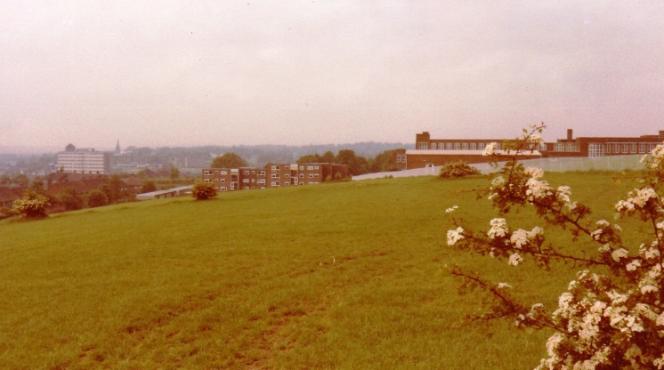 | 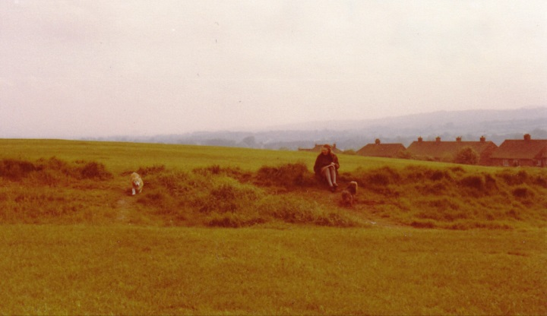

1. The Croft in Spring 1981 before the old hedges were reinstated on the existing hedge banks and before a more varied maintenance and management regime was agreed with Stoke-on-Trent City Council.
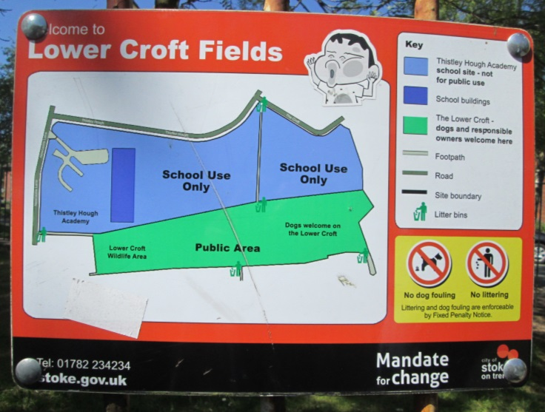 | 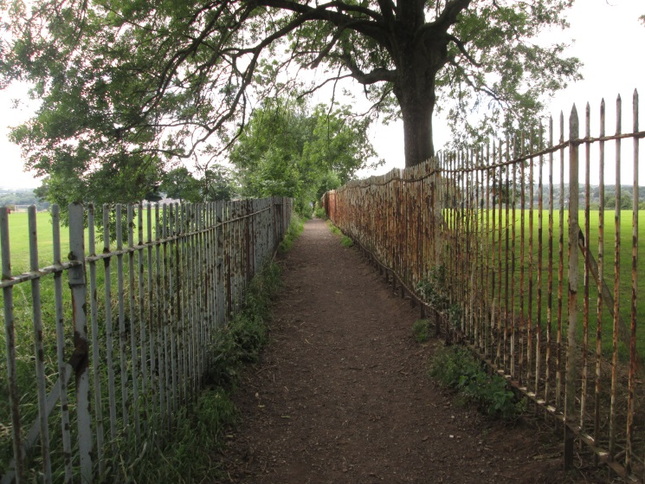
2. Welcome sign at The Croft Road entrance. | 3. The entrance to The Croft from Croft Road and Thistley Hough in July 2020.
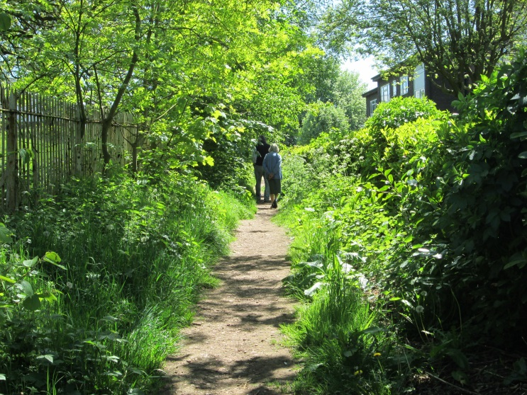 | 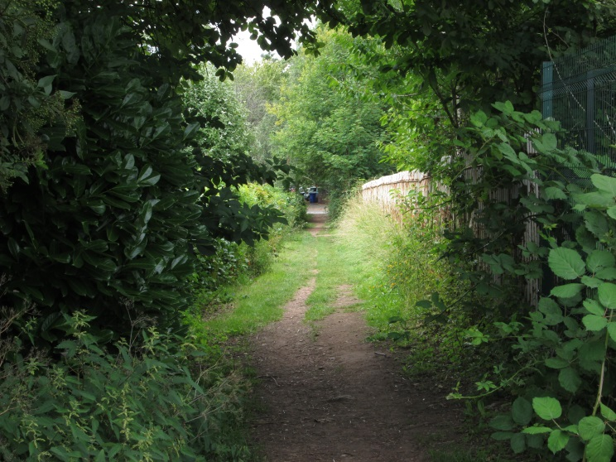
4. Access to The Croft from Newcastle Lane (May 2018) illustrating its ‘rural’ character. | 5. Looking along the same access in July 2020 towards Newcastle Lane.

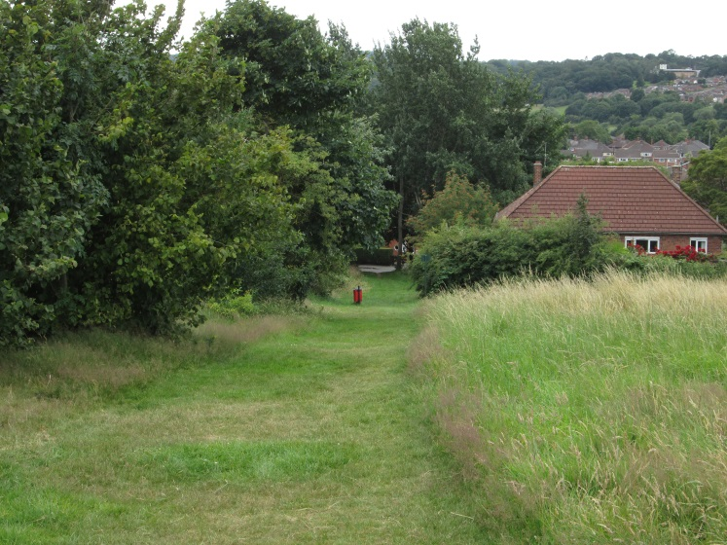

6. An access route from Springfields showing one of the hedgerows on the left hand-side, a mown grass path contrasting with the longer tussock grass and the view south beyond the urban area. (July 2020) | 7. Looking north towards the Marchwood Court flats on Newcastle Lane, illustrating the gentle slope of the land and the various vegetation types which contributes towards its semi-natural character. (July 2020)
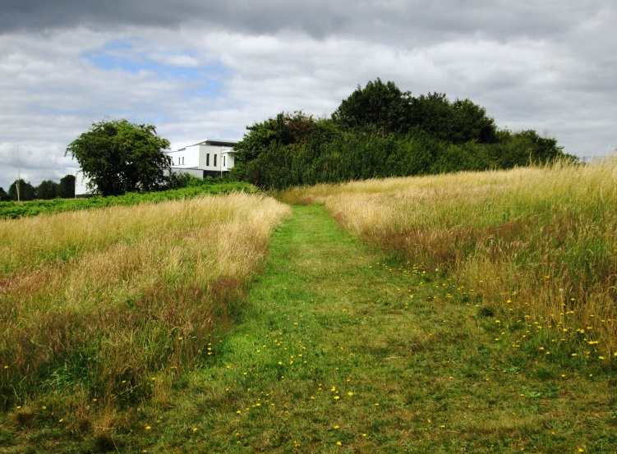 | 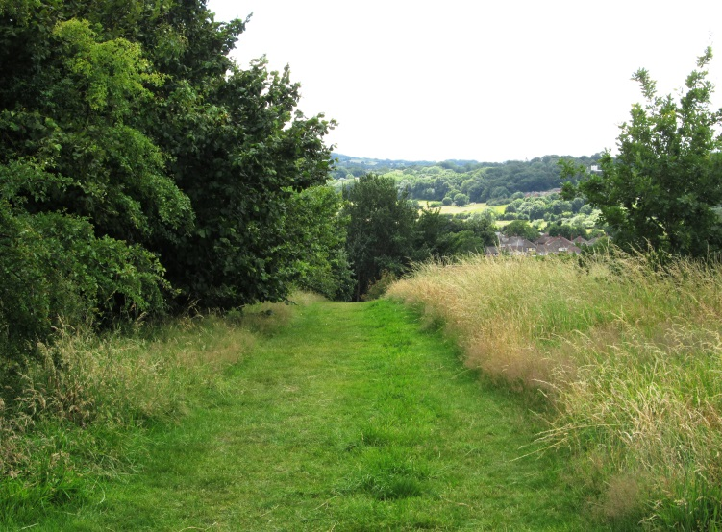
8. Looking east along a mown path up towards Thistley Hough Academy. (July 2020) | 9. A framed view south along a mown path and to the rural landscape beyond The Croft and the urban area.
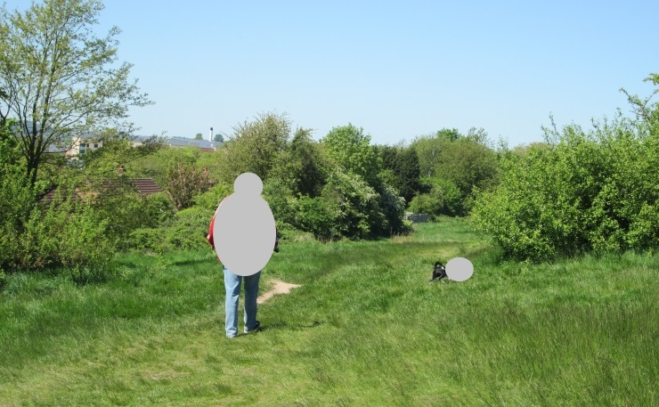 | 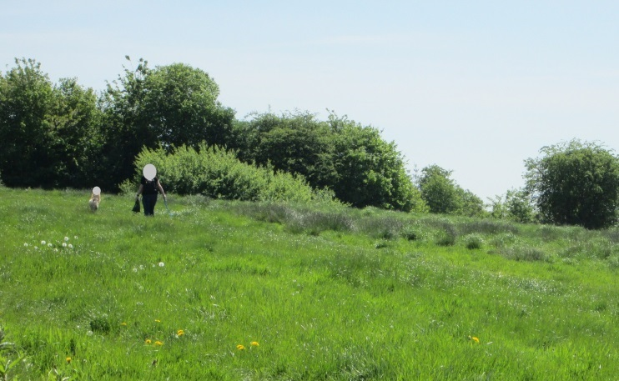
10. Walking the dog. (May 2018) | 11. Walking the dog. (May 2018)
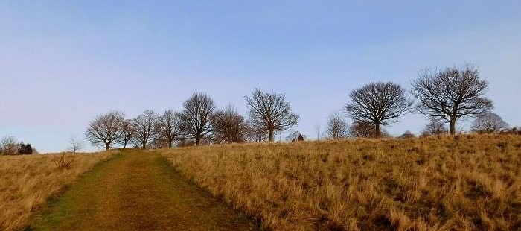

12. A Winter view eastwards (December 2019)
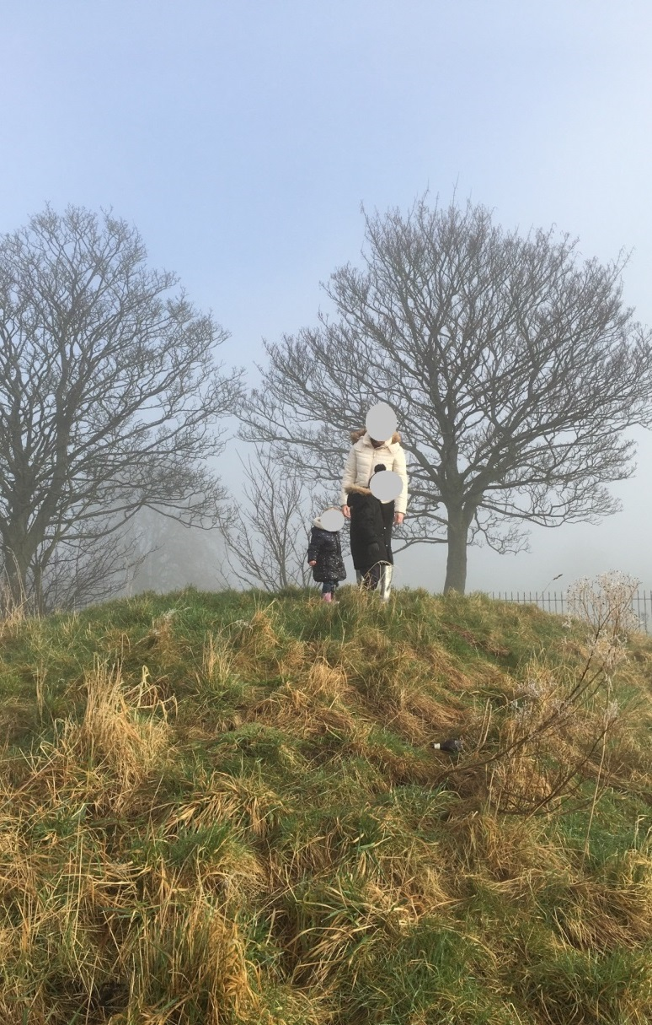
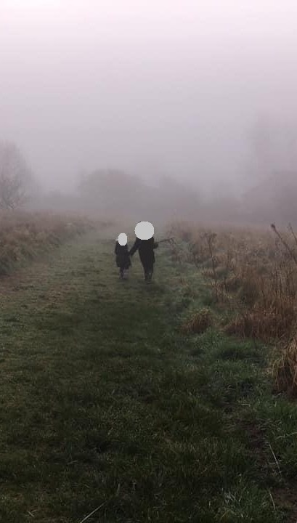

13 and 14. A family visiting The Croft in different winter weather conditons (Early 2020)

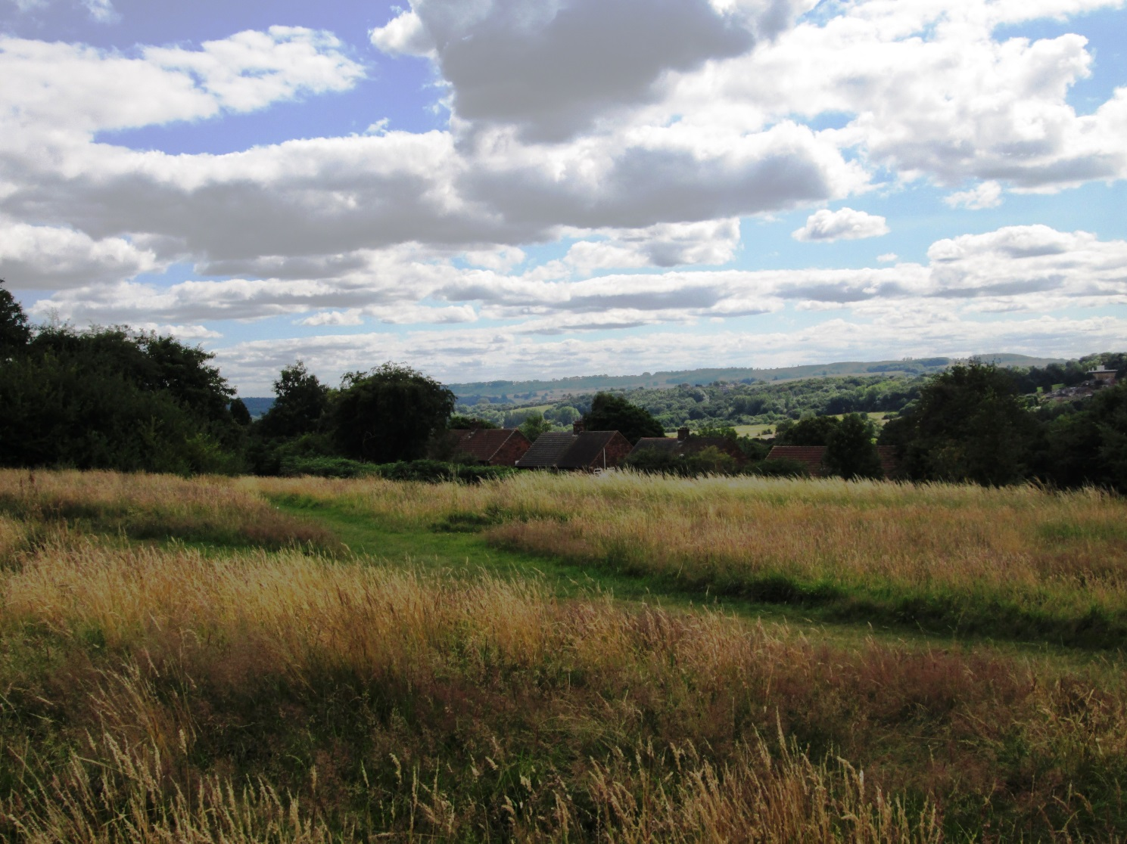

15 and 16. In the foreground The Croft slopes gently down towards the south with a mosaic of vegetation types; mown grass, tussock grass, hedgerows and individual trees. The openness and elevation of The Croft affords panoramic views out towards the countryside beyond, the Hanchurch Hills with their wooded slopes. (July 2020)
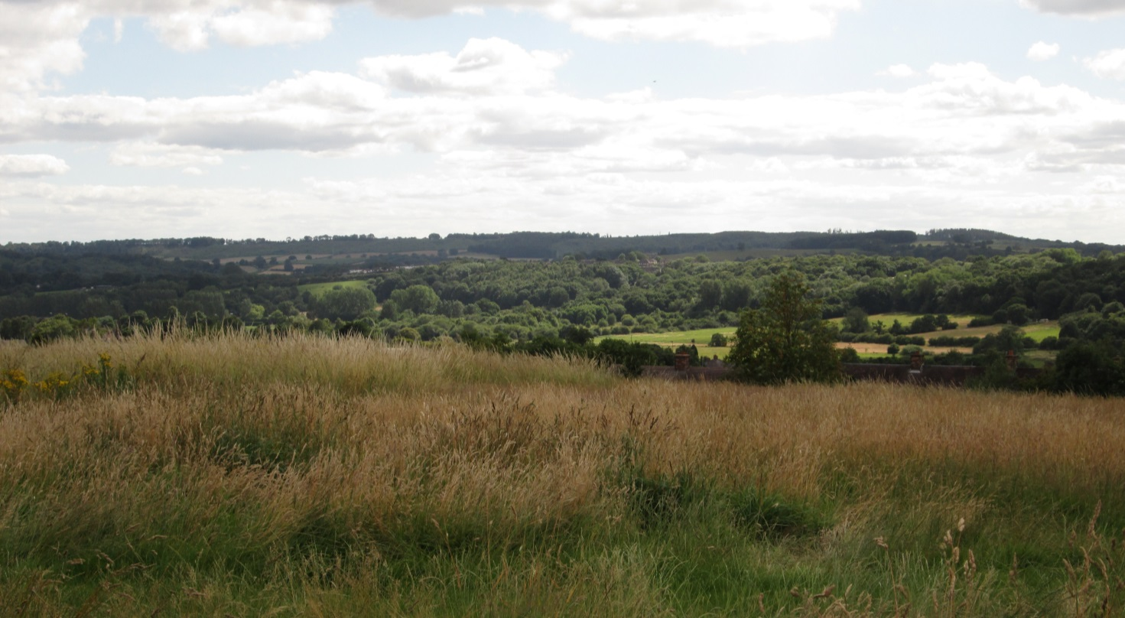

Appendix C

Richness of Wildlife-Biodiversity
Over a number of years records have been made of ‘wildlife’ sightings on The Croft. Appendix C lists the records of grasses, wildflowers, trees and shrubs, birds, insects, fungi, butterflies and moths with notes.
Grasses | Common Name | Notes
Agrostis capillaris | Common Bent
Anthoxanthum odoratum | Sweet vernal grass
Aria preacox | Early Hair-grass
Cynosurus cristatus | Crested Dog’s-tail
Dactylis glamerata | Cock’s-foot
Deschampsia flexuosa | Wavy Hair-grass
Festuca rubra | Red fescue
Holcus lanatus | Yorkshire Fog
Lolium perenne | Perennial Rye-grass
Luzula campestris | Field Wood-rush
Poa trivialis | Rough meadow grass

Wild Flowers | Common Name | Notes
Anthriscus sylvestris | Cow parsley
Calluna vulgaris | Heather
Centaurea nigra | Black Knapweed
Cerastium fontanum | Common Mouse-ear
Chamerion angustifolium | Rosebay Willowherb
Conopodium majus | Pignut
Galium saxatile | Heath bedstraw
Hieracium agg. | Hawkweeds
Hypochaeris radicata | Common Cat’s ear
Leontodon autumnalis | Autumn Hawkbit
Pilosella aurantiaca | Fox and cubs
Plantago lanceolata | Ribwort plantain
Pteridium aquilinum | Bracken
Ranunculus acris | Buttercup
Ranunculus bulbosus | Buttercup
Rumex acetosa | Common sorrel
Rumex acetosella | Sheep’s sorrel
Senecio jacobaea | Ragwort
Trifolium pratense | Red clover
Trifolium repens | White clover

Trees and shrubs | Common Name | Notes
Acer campestre | Field maple
Buddleia davidii | Butterfly Bush
Cornus sanguinea | Dogwood
Corylus avellana | Hazel
Crataegus monogyna | Hawthorn
Cytisus scoparius | Broom
Fraxinus excelsior | Ash
Malus sylvestris spp sylvestris | Crab apple
Prunus spinosa | Blackthorn / Sloe
Quercus robur | Pedunculate oak
Rosa canina | Dog rose
Rubus fruticosa | Bramble
Sambucus nigra | Elderflower
Sorbus aucuparia | Rowan / Mountain ash
Ulex europeaus | Gorse
Viburnum opulus | Guelder Rose

Birds | Common Name | Notes
Accipiter nisus | Sparrowhawk
Aegithalos caudatus | Long tailed tits
Alauda arvensis | Skylark | Passage/ BAP Principal Species/ BoCC4 Red
Anthus pratensis | Meadow pipits | Passage/ BoCC4 Amber
Apus apus | Swifts | BoCC4 Amber
Ardea cinerea | Heron
Buteo buteo | Buzzard
Carduelis cannabina | Linnets | BAP Principal Species/ BoCC4 Red
Carduelis carduelis | Goldfinch
Chloris chloris | Greenfinch
Columba livia | Feral pigeon
Columba palumbus | Woodpigeon
Corvus corax | Ravens
Corvus corone | Crows
Cyanistes caeruleus | Blue Tit
Delichon urbicum | House Martins | BoCC4 Amber
Erithacus rubecula | Robin
Falco tinnunculus | Kestral | BoCC4 Amber
Hirundo rustica | Swallows
Larus fuscus | Lesser Black-backed gulls
Oenanthe sp. | Wheatear | Passage
Passer domesticus | House Sparrow | BAP Principal Species/ BoCC4 Red
Periparus ater | Coal tits
Phylloscopus trochilus | Willow warbler
Pica pica | Magpies
Pluvialis apricaria | Golden plover
Prunella modularis | Dunnocks | BoCC4 Amber
Psittacula krameri | Ring necked parakeets | Rare, transitory species to the Croft/Thistley Hough, one person sighted a small flock 3 times in 2019)
Regulus regulus | Goldcrests
Strix aluco | Tawny owl (Resident) | BoCC4 Amber
Sturnus vulgaris | Starlings | BAP Principal Species/ BoCC4 Red
Sylvia atricapilla | Blackcaps
Sylvia communis | Whitethroat | Summer migrant
Troglodytes troglodytes | Wren
Turdus iliacus | Redwing | Winter migrant
Turdus merula | Blackbirds
Turdus philomelos | Song Thrush | BAP Principal Species/ BoCC4 Red
Turdus pilaris | Fieldfare | Winter migrant/ BoCC4 Red
Turdus viscivorus | Mistle Thrush | BoCC4 Red

Insects | Common Name | Notes
Aeshna grandis | Brown Hawker Dragonfly
Andrena cineraria | Ashy Mining bees | BAP Principal Species
Andrena fulva | Tawny Mining bees
Andrena haemorrhoa | Early/ Orange Tailed Mining bees | BAP Principal Species
Andrena sp. | Mining bees | BAP Principal Species
Apis mellifera | Honey bees
Bombus sp. | Bumble bees | BAP Principal Species
Carabus violaceus | Violet ground beetle | BAP Principal Species
Ctenicera cuprea | Click beetle
Lindenius albilabris | Mining bee | BAP Principal Species
Ocypus olens | Devils Coach-horse beetle
Omocestus viridulus | Common Green Grasshoppers
Syrphidae | Hoverflies

Fungi | Common Name | Notes

Boleutus sp.
Clavulinopsis corniculata | Coral fungus
Clavulinopsis luteo alba | Apricot Club fungus
Concybe tenera | Common cone cap fungus
Cuphophyllus pratensis | Meadow Waxcap
Gliophorus irrigatus | Slimy Waxcap
Hygrocybe coccinea | Scarlet Hood / Scarlet Waxcap
Hygrocybe ceracea | Butter Waxcap
Lycoperdon foetidum | Dusky puffball

Butterflies and Moths | Common Name | Notes
Abraxas grossulariata | Magpie moth
Aglais lo | Peacock
Aglais urticae | Small Tortoiseshell
Aphantopus hyperantus | Ringlet
Gonepteryx rhamni | Brimstone
Lycaena phlaeas | Small Copper
Maniola jurtina | Meadow Brown
Ochlodes sylvanus | Large Skipper
Parage aegeria | Speckled Wood
Pieris brassicae | Large white
Pieris napi | Green veined white
Pieris rapae | Small white
Polygonia c-album | Comma
Pyronia tithonus | Gatekeeper
Vanessa cardui | Painted lady

Appendix D – Community Comments

NPPF para 100b - Confirmation that The Croft is “demonstrably special to a local community”

STOP THE DEVELOPMENT OF THE CROFT
A petition to Stoke-on-Trent City Council was started some 10 months ago with, to date, 568 signatures. The petition was introduced with the following text:
“The Croft has been used by dog walkers, nature lovers, children and families for years. The Croft is one of the few large, open green spaces left in Penkhull and development of the Croft will further contribute to decreasing air quality in a city that has already been ranked in the top 32 cities/towns in the UK for poor air quality. The development of the Croft will not only impact the current generation of residents in Penkhull, but future generations also. The area is a site on which many people walk their dogs, children play and make memories.
Please help to end this development by signing this petition and show Stoke Council the discontent for their decision to use the Croft as a development site.”
The following are a small selection of the reasons people gave for signing the petition which demonstrates why the Croft is special to the local community; (note names have been removed).
Other comments can be viewed at https://www.change.org/p/stoke-council-stop-the-development-of-the-croft
November 2019
No no no , leave the Croft alone soon there will be no open spaces not to mention all the plants and wildlife that will be destroyed
November 2019
Don’t take away the only bit green in the area.
November 2019
Had a great childhood there. Also played a lot of football on that pitch. Lots of great memories
November 2019
Development on the Croft needs to be stopped. Not only will it affect the people of Penkhull, but also the wildlife that lives there.
November 2019
This is a beautiful open green space that benefits a large community of all ages, all year round. It has far reaching views of Trentham/ Clayton and Newcastle. We also get some stunning sunrise & sunsets which change during each season. The trees & the wildlife need to be preserved. Use up the derelict areas in Penkhull that make the village look messy and unkempt before looking at developing our beautiful green open areas.
November 2019
The council should be trying to provide us with more green open spaces, do they not know about climate change, and how important green open spaces are for our health and wellbeing, Mental health has been highlighted as something we need to address, the croft provides a safe place for us to enjoy with our families and dogs, we have this wonderful place on our door step, it needs protection for us and future generations.

27 Nov 2019
It has always been an important space for sport & play for all of us from Penkhull & Trent Vale. We need more fresh air/open spaces to encourage better mental & physical health for all. There are plenty of alternative derelict industrial premises that could be developed more productively.
December 2019
There are no other ‘natural’ Green spaces in walking distance of Penkhull. The array of birds seen and heard, not to mention other wildlife that lives in that Green natural habitat, plus the varied tree species including young Oak trees. The city needs all the help it can get to be ‘cleaner’ with better air quality etc... apparently asthma and other allergies are at an all-time high, everyone should be safeguarding green land end of…
December 2019
Penkhull deserves to keep a much needed green space. It's a lovely area but incredibly developed and it's residents deserve to have this area preserved. Stoke has plenty of brownfield areas begging to be developed. No need to destroy our limited in city open green spaces.
December 2019
This is a beautiful place for so many people of all ages a quiet peaceful haven for not only our locals but all the precious wildlife….
December 2019
This is a beautiful part of Penkhull that we all enjoy, the only part of Penkhull where we can go to enjoy the open space to walk or walk our dogs, a place for children to enjoy, and what about the wildlife, please leave the croft alone.
December 2019
Green spaces are essential for health and wellbeing of humans. Stoke on Trent needs more green spaces not less. There are other more suitable areas to build houses. Penkhull has a village community spirit don’t break it.
December 2019
We enjoy walking around the Croft and having a picnic enjoying the views in the summer. There’s not many places around here that you can visit for free with children and enjoy such a thing.
December 2019
This would take a lot of joy from many people! So many walk there, I’ve loved many a sunset from this place. Please don’t take that joy from so many
December 2019
I used to play there when I was small and had so much fun. My father played there when he was young too. Please leave it for others to have fun be young and enjoy the beautiful Croft as it has been for hundreds of years.
December 2019
It's one of the best sunset spots in Stoke we need to protect this
January 2020
Children play here..... I played here 40years ago. Where else will they go.

References
A spatial analysis of proximate greenspace and mental wellbeing in London, by Victoria Houlden, João Porto de Albuquerque, Scott Weich, Stephen Jarvis:( Universities of Warwick, Newcastle and Sheffield) published in Applied Geography, Volume 109, 2019

Bringing Nature into the City - Landscape: The Journal of the Landscape Institute; Issue 3, 2020

Environment Act (2021)

Fields in Trust: Guidance for Outdoor Sport and Play: Beyond the Six Acre Standard 1930-2015.

Landscape Institute: Green Infrastructure: Connected and Multi-Functional landscape (March 2013)

Landscape Institute: Public Health and Landscape, Creating Healthy Places (November 2013)

Natural Environment and Rural Communities Act (2006)

Penkhull Remembered Again, Richard Talbot (1980)

Stoke-on-Trent Live February 2018, Phil Corrigan: Hundreds fighting plans for 191 homes to be built on these fields in the most ancient part of city

Stoke-on-Trent Local Plan Issues and Options Consultation Summary (May 2021)

Sustainability Appraisal Scoping Report (April 2021)

The Biodiversity Strategy 2020, A strategy for England’s wildlife and ecosystem services (2011)

The City of Stoke-on-Trent Green Space Strategy (November 2018; update 2021)

The City of Stoke-on-Trent Local Plan (September 1993)

The Local Development Framework Newcastle-under-Lyme and Stoke-on-Trent Core Spatial Strategy 2006-2026 (adopted October 2009)

The National Planning Policy Framework July 2018, (amended February 2019)

The National Planning Practice Guidance: ‘Open space, sports and recreation facilities, public rights of way and local green space’, (March 2014)

The Natural and Rural Environment Technical Paper, issued as part of the Local Plan consultation (2018)

The Nature Nearby Accessible Natural Green Space Guidance; Natural England (March 2010)

The Royal Manor of Penkhull, Richard Talbot (2010)

The Staffordshire Biodiversity Action Plan (2010)

The Stoke-on-Trent Biodiversity Opportunities Map (2014)

The Stoke-on-Trent Greenspace Strategy (2014)

The Urban North Staffordshire Green Space Strategy (Dec 2007); North Staffordshire Regeneration Partnership - the City of Stoke-on-Trent and Newcastle under Lyme Borough

UK Biodiversity Action Plan; (1992)

